**Report of Signal Processing**

1. Load the images in Matlab and convert them to double.

Because I transfer the tif figures into jpg in advance, I did not change it into double.

1. After visualize the images:

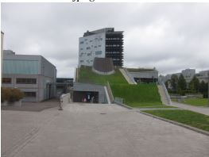

nature out of focus

1. Segment the images into subchannels Ic (R,G,B).

Choose the RGGB separately,

'rggb' = R G R

G B G

R G R

A bayer filter mosaic is a color filter arranging RGB color filters on a square grid. It's pattern is 50% green, %25 red and %25 blue. Hence it is also called BGGR, RGBG, RGGB. It's based on using twice as many green (luminance-sensitive) elements as red or blue (chrminance-sensitive) to mimic the physiology of the human eye.

1. Analyze each subchannel of the out-of-focus image: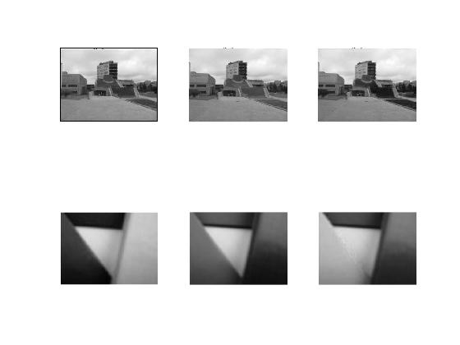

In every channel, the higher intensity gives darker value. The green color is brightest in the channel green picture, for example the lawn is apparently brighter in the middle picture. (.mat results can be seen in the accessory. Similarly, the red part as in the right picture is brightest in the red channel and the part which is blue is brightest in the blue channel as shown in the bottom right picture. (The picture after the Bayer pattern plot is not as shown here because of some strange reason, here is no result for the outcoming but just the black sceen. The code used is actually from one course before when I had the correct results. )

)

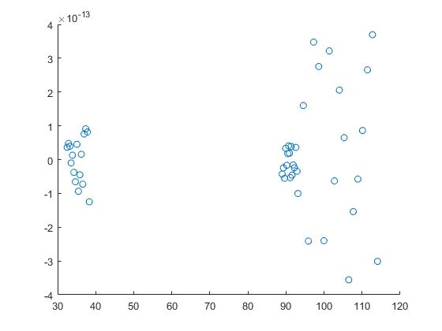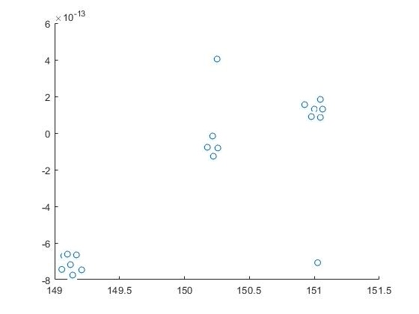

According to the variance, the red, green and blue three different channels have different results leaving the variance spreaded at similar range for them. The highest variance of the channel occurs at red, then comes the yellow and final is the blue. For the second picture, variance-mean can also be analyzed through the scatter plot. The red channels are of the negative variance which is the largest showing the most noise included, the green variance is the smallest very close to zero showing the least noise while the blue is the second showing the variance around 2.

1. According to the figure below, the lines fitted in the picture as the slope is close

to 2.Still, there are several intensities are not fitted on the line. The slope being 2 also makes the shift from one channel to another keeps regularly at the ratio 2.

a1 = 1.9731e %(-8.165e-3, 8.36e-3)

b1 = 1.196 %(-1.225, 1.255

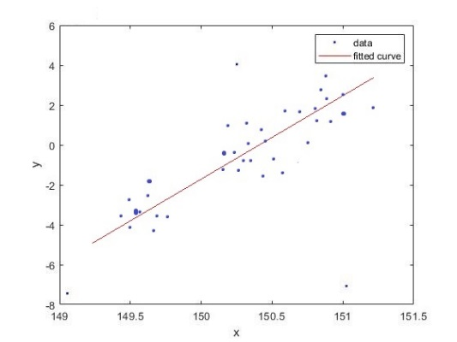

1. The fit lines of the out-of-focus image is slightly different after the transformation. It is clear that,

a2 = 1.568e-5 %(-1.15e-5, 1.743e-5)

b2 = 1.142 %(-1.061, 1.33)

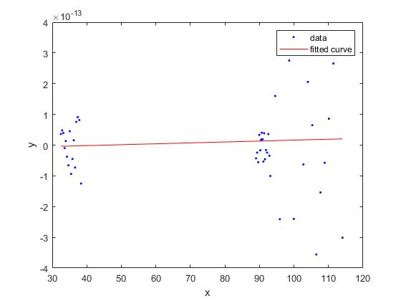

1. According to the transformation coefficients, the a2(1.568*10^-5) is close to 0 and b2 is close to 1. Thus, the line is slightly flatter. In addition, the variances distributs symmetrically around zero although not all closes to zero. And the shift between one channel to another channel is not significantly large making them too different.
2. After the DCT, The result is :

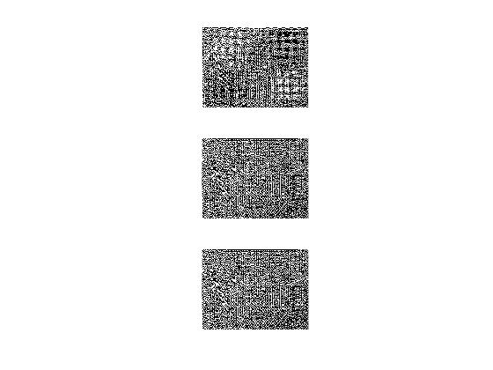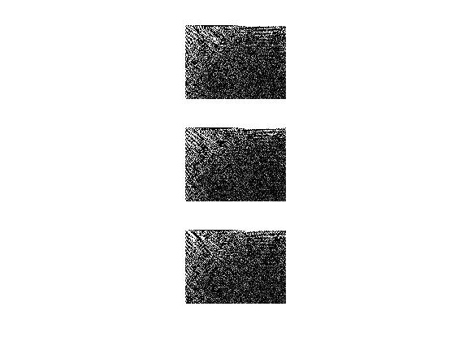

* + 1. Compute the mean-variance.

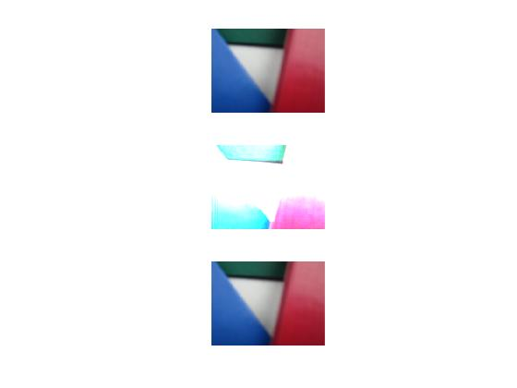

According to the picture, the origin after the root transform becomes the brighter. The green channel is transferred the most. The result of the one after inverse transform is also quite good although it is not the forward root transform. It might because the inverse transform work on the frequency domain which does not require it to be necessarily the inverse of the root. Because mapping the source of the root transformation pixel only needs to be the related source.

12. 13.

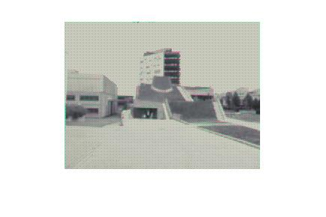 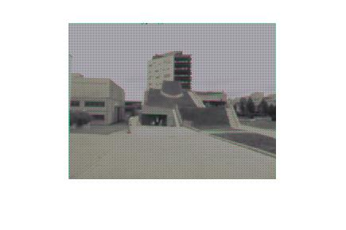

The next stage is to compose a new image and try to imply the white balance to it. The one after the white balance is on the left and the one after gamma transformation is in the right. According to the picture, the white balance makes the pixel with highest intensity turns to white while the gamma transformation makes the rise of the intensity non-linear and is faster than linear which makes it a little bit dark.

Qin He

10110032